**This is not a photo.**

Photo 12 is colorful.

Photo 4 is **DARK**!

This is a photo.

This is a

brand-new photo.

This is a good photo.

More information: [www.mybestphoto.com](http://www.mybestphoto.com) or [info@mybestphoto.com](mailto:info@mybestphoto.com).

+33 6 45 98 61 78

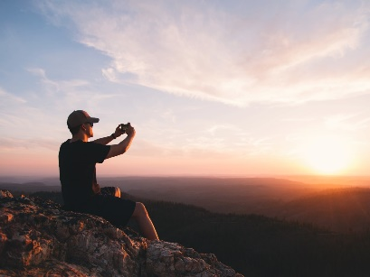This is a terrible photo, I will edit it.

Please edit this photo.Change this photo.

Please replace the recurring expression “This is a”!